AI Assisted coding
Assignment-4.1
Name: Shashikanth G
HT NO.: 2403A51245
Batch No.: 11
Task-1
Use zero-shot prompting to instruct an AI tool to generate a function that validates an Indian mobile number.
Requirements
- The function must ensure the mobile number:
  - Starts with 6, 7, 8, or 9
  - Contains exactly 10 digits
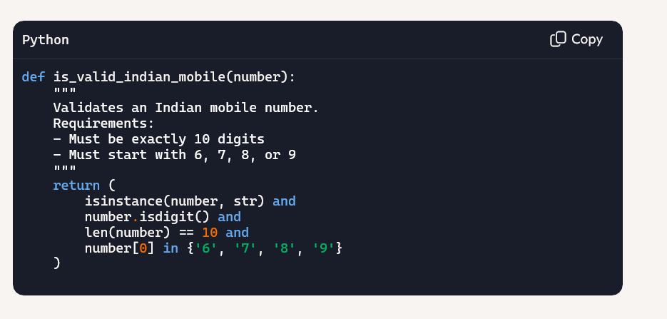

Output:
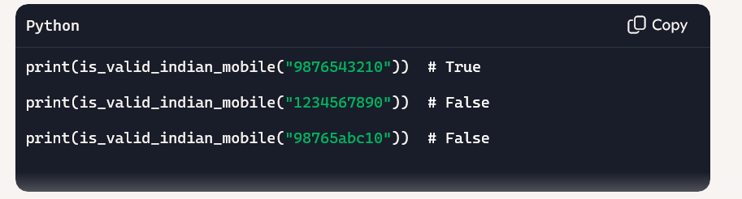
Task-2:
Use one-shot prompting to generate a Python function that calculates the factorial of a number.
Requirements
- Provide one sample input-output pair in the prompt to guide the AI.
- The function should handle:
  - 0! correctly
  - Negative input by returning an appropriate message

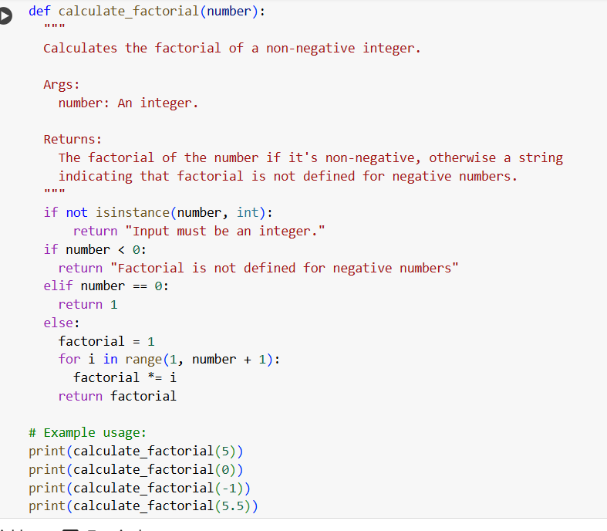

Output:
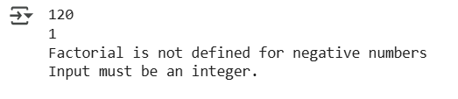
Task-3:
Use few-shot prompting (2–3 examples) to instruct the AI to create a function that parses a nested dictionary representing student information.
Requirements
- The function should extract and return:
  - Full Name
  - Branch
  - SGPA
- 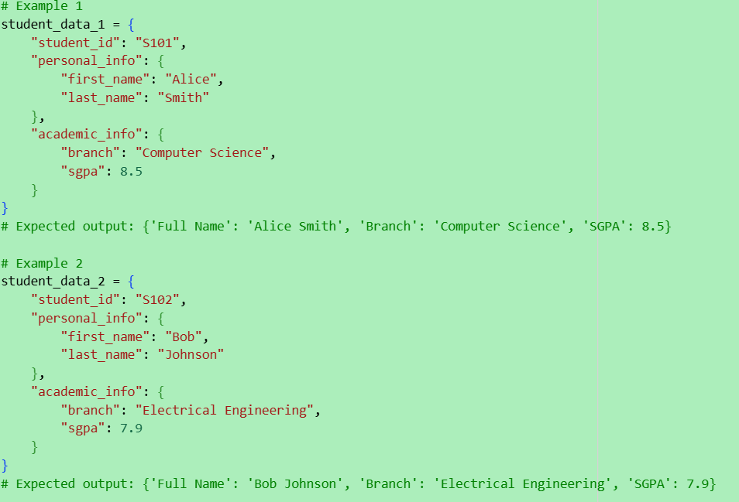

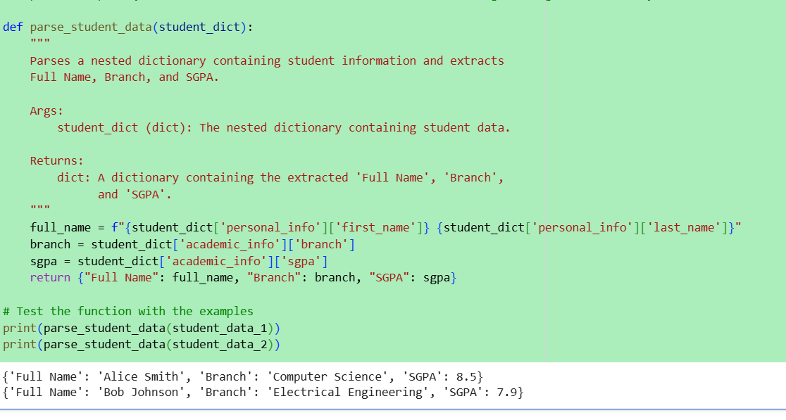

Task-4:
Experiment with zero-shot, one-shot, and few-shot prompting to generate functions for CSV file analysis.
Requirements
- Each generated function should:
  - Read a .csv file
  - Return the total number of rows
  - Count the number of empty rows
  - Count the number of words across the file
- 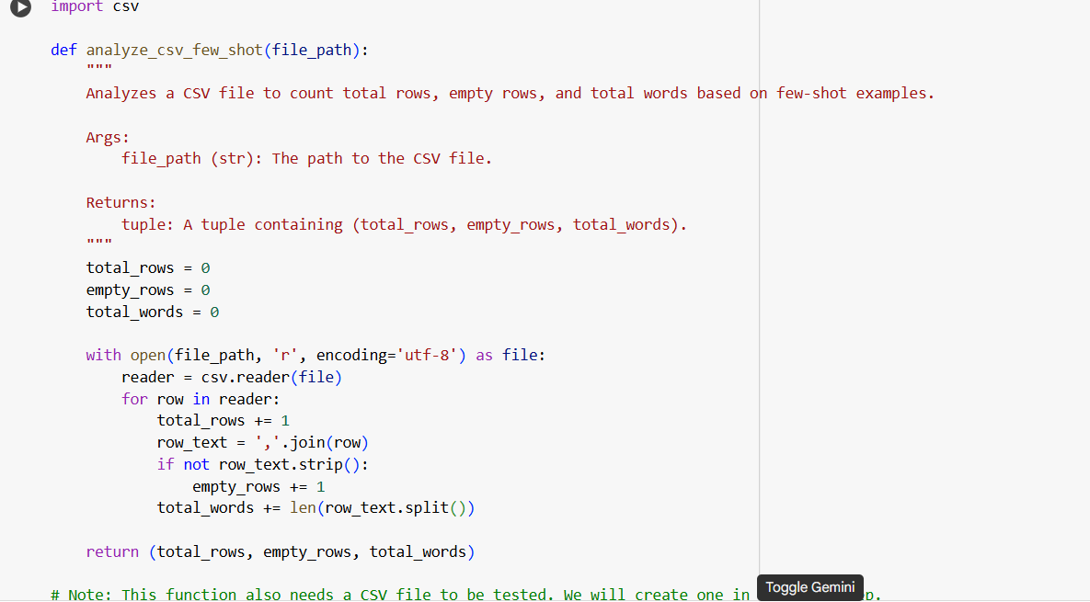
- 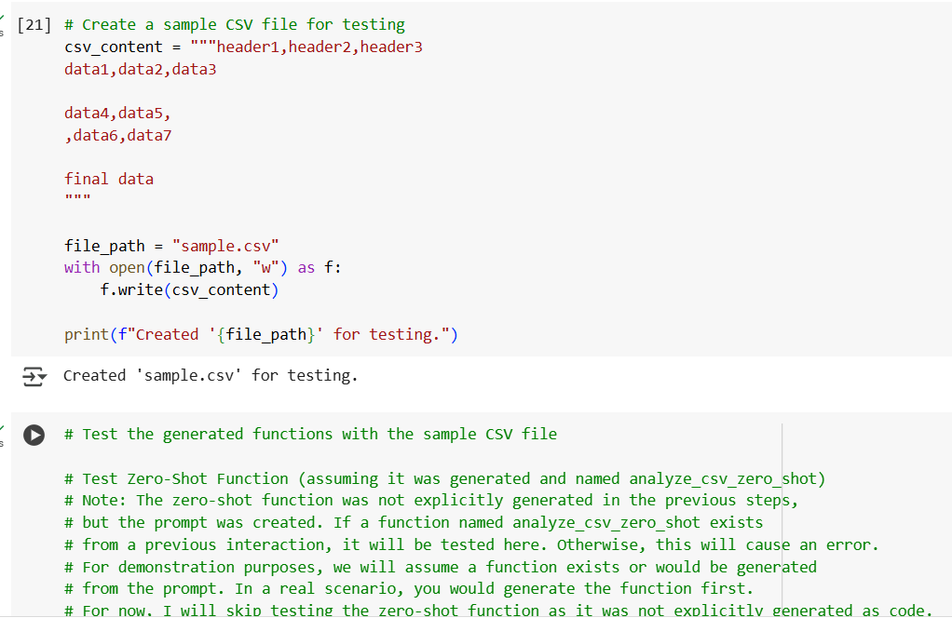
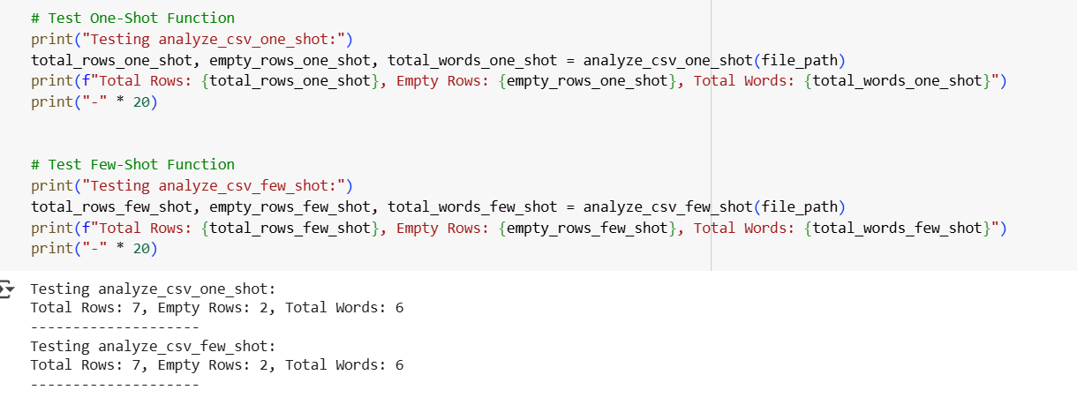
Task-5:
Use few-shot prompting (with at least 3 examples) to generate a Python function that processes text and analyzes word frequency.
Requirements
The function must:
- Accept a paragraph as input
- Convert all text to lowercase
- Remove punctuation
- Return the most frequently used word
Expected Output
- A functional Python script that performs text cleaning, tokenization, and returns the most common word using only the examples provided in the prompt

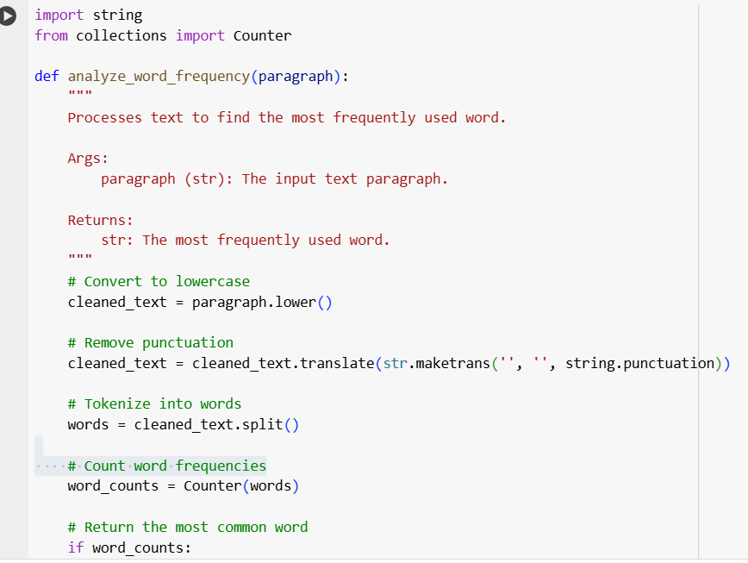
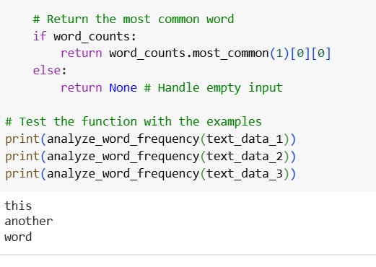
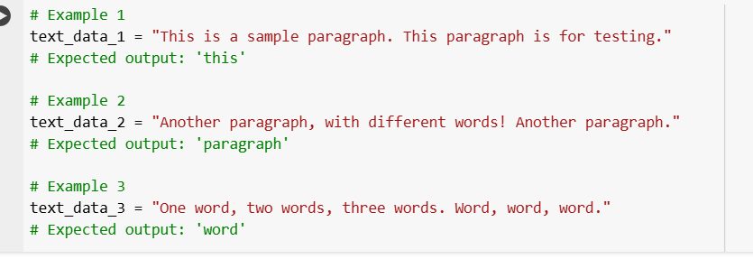

Explanation:
Certainly. The code I provided demonstrates how to use few-shot prompting to generate a Python function for text processing and word frequency analysis.
Here's a breakdown of the code:
- Markdown Cells: The markdown cells provide the context for the few-shot prompting. They introduce the task and present three examples (text_data_1, text_data_2, and text_data_3) with their expected outputs. These examples serve as the "shots" to guide the AI model in generating the desired function.
- Code Cell with Examples : This cell defines the three example text snippets (text_data_1, text_data_2, text_data_3) that were mentioned in the markdown cell. These are the inputs used to illustrate the function's expected behavior.
- Code Cell with Function Definition : This is the core of the solution. The analyze word frequency function is defined here.
  - It imports the string module for punctuation handling and Counter from the collections module for counting word frequencies.
  - It takes a paragraph string as input.
  - cleaned_text = paragraph.lower(): Converts the input paragraph to lowercase to ensure that words like "This" and "this" are counted as the same word.
  - cleaned_text = cleaned_text.translate(str.maketrans('', '', string.punctuation)): Removes punctuation from the text. str.maketrans('', '', string.punctuation) creates a translation table that maps each punctuation character to None, effectively removing them when translate() is applied.
  - words = cleaned_text.split(): Splits the cleaned text into a list of individual words based on whitespace.
  - word_counts = Counter(words): Uses the Counter object to count the occurrences of each word in the words list.
  - if word_counts: return word_counts.most_common(1)[0][0] else: return None: This part finds the most common word. word_counts.most_common(1) returns a list of the single most common word and its count (e.g., [('word', 3)]). [0] accesses the first element of this list (the tuple), and [0] again accesses the word itself from the tuple. The if word_counts: check handles the case of an empty input paragraph.
- Testing the Function: The print() statements at the end of the function definition cell call the analyze_word_frequency function with the example text data and print the returned most frequent word, demonstrating that the function works as expected based on the few-shot examples provided.
In essence, the few-shot prompting approach involved showing the AI what kind of input the function would receive and what the corresponding output should be for a few different cases. This guided the AI to generate the Python code that performs the necessary text cleaning, tokenization, and frequency analysis to achieve those results.

